**Your First Solo Notes**

**Lesson 1: Pre-Solo Maneuvers**

* Includes **S turns** and **turns around a point**
* A constant bank turn with any wind will result in a ground track that differs from a constant
* To make a circle bank angle must be varied with the wind
  + **Upwind side:** Decrease bank angle as groundspeed decreases to maintain the circle
  + **Downwind side:** Increase bank angle as groundspeed increases
* **S – Turns across a road**: Plane makes semi-circles on each side of a straight road
  + Flown **600 – 1000 ft above ground level (AGL)**
  + Road should be at a right angle to the wind
  + Start a right angle to the road heading away from the wind
  + Make a 180 turn over the road
  + Complete the turn at a right angle to the road with wings level
  + Repeat the process on the other side of the road
* At the beginning of the turn bank should be steepest
* The greatest crab angle will should occur when the plane is 90 crosswind
* When you are directly crosswind pick a point on the road to finish the cross
* **Turns Around a Point:** Constant altitude turn that maintains a constant distance from a point.
  + Pick an identifiable marker like a four-way intersection
  + Begin a turn and project ahead by picking a marker to cross with a certain reference distance
  + Change you bank angle similar to how you do during an S turn depending on your relation to the wind.
* **Warning: Never exceed a 45 bank during the turns!**

**Lesson 3: Steep Turns**

* **Airplane Load Factor:** At earths surface the force on an airplane at rest is 1G( 1 Gravitational Weight)
* **Load Factor:** Aerodynamic stress on the airplane
  + A load factor of **2Gs** indicates twice the planes weight and usually occurs in a **60** bank
  + Airplane maneuvering limit load factors typically have 3 categories

1. **Normal:** **3.8** positive Gs, **1.52** Negative Gs
2. **Utility: +4.4** Gs , **-1.76** Gs
3. **Acrobatic:** +**6** Gs, **-3** Gs
   * Planes typically have a safety margin limit of 1.5 times the maneuvering load factor

* The load factor of a turn during a constant altitude turn is purely bank angle dependent.
  + **30 = 1.15** Gs
  + **45 = 1.41** Gs
  + After 45 degrees the load factor increases exponentially
  + **60 = 2** Gs
  + **70 = 2.92** Gs
* A higher load factor will make the plane stall at a higher speed
* Load factor on a stalled plane can’t exceed **1 G**
* Elevator back pressure during a turn will modify the load factor
* Some acrobatic planes are equipped with a **G-meter** to measure load factor
* For non acro planes seat of the pants flying is a reliable measurement
* **Maneuvering Speed (V­­­A):** The speed at which an airplane stalls before exceeding the design limit loads
  + Changes based on the weight of the airplane
  + Should not be exceeded in rough air
* **Steep turn execution:**
  + Should be flown above 1,500 ft AGL
  + Clear the area and check for other aircrafts first
  + Fly the aircraft below or at the maneuvering speed.
  + The increased AOA needed to maintain high lifting component will a higher pitch attitude than a medium bank turn
  + Rate of turn will be between 9 and 12 degrees per second
  + **45 degrees is not marked on the attitude indicator**
    - Align the wings of the artificial airplane with the ground reference line on the attitude indicator

1. First pick a reference point outside to determine your turn
   1. For the private pilot test you need to perform a 360 degree turn and stay within 100ft.
2. Add aileron pressure for long enough to reach 45 degree bank
3. Increase power and elevator pressure to maintain altitude
4. If you start losing altitude shallow the bank and then pull back slightly on the elevator to regain it
5. If you start to climb increase bank or reduce the back pressure on the elevator.
6. You may need to use some rudder to keep the turn coordinated
7. Begin rollout with opposite aileron pressure within 25 to 35 degrees of the target point.

**Lesson 5: Emergencies**

* **FAR 91.3 (b) :** *In an in-flight emergency requiring immediate action the pilot in command may deviate from any rule of this part to the extent required to meet that emergency.*
* **You can deviate from the rules in an emergency to save the plane, yourself and others on the ground!!!**
  + The FAA may ask later for a report on the emergency, but if they don’t ask then a report is not required.
* If on the takeoff roll the engine doesn’t feel right or is performing unusually abort takeoff before V1 and Taxi back to have it checked.
* **Engine Failure After:**
  + Don’t turn back to the airport
    - You likely won’t make it
  + Immediately lower the nose and pitch for best glide speed
  + Pick the most suitable landing spot
  + If you are below 200 ft AGL keep turn banks under 20 degrees (shallow)
* **Partial Engine power failure**
  + Fly straight ahead and gain some altitude
  + Keep turns shallow
  + Gradually turn back to the airport and land on some runway
  + Land normally in the pattern if you still have power
* **Instructor simulated failures**
  + Know the wind direction beforehand
  + Fly the airplane and establish speed for best glide
  + Pick a good landing site and spiral down over it
  + Land on a normal approach if possible
* **In any emergency after deciding a potential landing spot perform the emergency procedures checklist and see if you can identify and fix the problem!**
* **Emergency checklist for Cessna Skyhawk(Engine Restart)**
  + Establish best glide speed of 65 Knots
  + Fuel shutoff valve ON
  + Fuel selector to BOTH
  + Auxiliary fuel pump on
  + Mixture to rich
  + Ignition switch to both (engage starter if prop is stopped)
* **If Engine does not restart Checklist**
  + Seats upright and belts secure
  + Mixture Idle cutoff
  + Fuel shutoff valve off
  + Ignition off
  + Flaps on (full flaps recommended)
  + Airspeed 60 knots
  + Master switch off when landing is assured
  + Unlatch the doors before touchdown
* Try to approach the landing with a normal glide
* Vary your turn to final with bank angle if you are too high
* **NEVER try to stretch the Glide by pulling!**
* **Instrument Failure Emergencies**
  + Your instructor could cover the airspeed indicator and altimeter to simulate the failure
  + You will need to learn and apply judgement skills for VFR to estimate attitude and altitude

**Please always check for and know your airplanes specific Emergency Checklist inside and out when you fly. It will include engine or electrical fire procedures and you don’t want to burn to death.**

**Lesson 7: Fog and Atmospheric Pressure**

* **The Three R’s of Weather**
* **Recognize, Respect, and Refrain** from flying into marginal or hazardous weather.

* Clouds are essentially weather Signposts in the air

* **Layered clouds (Stratus):** Indicate stable conditions
  + Usually retards vertical movement of air
  + Expect a smooth flight with fair to poor visibility
  + Nimbostratus cloud is a stratus cloud producing precipitation
  + Light rain or snow when precipitating
  + Found on or within a few feet of surface = Fog

* **Cumulus Clouds:** Extensive vertical development
  + A sign of unstable air
  + Expect a bumpy flight with relatively high visibility
  + Rain or snow is usually heavy and localized
  + The unstable air can cause a convective current leading to vertical development
  + Can carry pollutants and dust away from surface improving surface visibility.

Earth’s Atmosphere

* **Troposphere**: lowest layer 0 to 40,000 feet
  + Temperature generally decreases with altitude
* **Stratosphere:** Second layer 10 to 50 KM
  + Temperature remains the same as altitude increases

* **Tropopause**: Boundary between both Troposphere and Stratosphere

* **Inversion:** A section where the temperature increases with altitude.
  + Can cause stable section of the atmosphere
  + Eliminates vertical movement of the air

* **Surface and Low Level Inversions:**
  + Pollutants such as fog, smoke, and dust can be trapped close to the ground causing poor visibility.

**Moisture Related Weather Conditions**

* The atmosphere is about 0.001% earth’s water but is responsible for all weather.
* **Fog and Thunderstorms** are two such moisture-related weather conditions.
* Humidity and energy stored in the water is relative to the temperature
* Colder air typically has less water vapor
* **At constant atmospheric pressure, Every 20 degree Fahrenheit increase in temperature doubles the maximum amount of water that an air mass can hold.**
* **Relative Humidity:** Relationship between amount of water vapor in the air and the maximum amount the air can hold at that temperature
* **Dewpoint:** Temperature at which relative humidity is 100%
* Water molecules need a kernel or Nucleus to condense
* **Condensation Nuclei:** Tiny particles in the air on which water condenses.
  + Typically dust, salt , combustion impurities or charged particles.
* **Warning:** When the temperature hits dew point, precipitation may begin if there are enough condensation nuclei. It may Rain or fog.

**Fog**

* Can happen before the relative humidity reaches 100%
* Occurs most commonly in the colder months
* Formed by addition of moisture to the air and/or cooling the air to the dew point. Combination of the 2 can work together

* **Radiation Fog /Ground Fog**
  + Terrestrial heat escapes and water vapor condenses at the surface layer due to cloudless, nocturnal conditions
  + Causes a surface level temperature inversion that can go to several thousand feet
  + Cooling of the air under the inversion causes fog to form
  + Light winds roll in the fog but strong ones disperse it
  + Happens late at night or early morning.
  + Won’t persist in strong temperature inversions or if clouds are above to absorb the energy
  + Rarely happens over bodies of water

* **Advection Fog / Sea Fog**
  + Caused by wind transport water vapor to a cooler surfaces
  + Formed when moist, warm air moves over a cold surface
  + Can also happen over snow in winter
  + Prevails along the coasts and great lakes of the Eastern U.S

|  |  |
| --- | --- |
| **Radiation Fog** | **Advection Fog** |
| Isolated | Widespread |
| Burns off quickly | Long- lasting |
| Night or early morning | Day or night |

* **Upslope Fog**
  + Very common around mountains or high elevation
  + Formed when moist, stable air is forced up a sloped surface by wind
  + Very dense and dissipates after the upslope wind ceases
  + The orographic lift can form cumulus clouds

* **Precipitation-Induced Fog**
  + Forms when precipitation evaporates as it falls.
  + The rain or drizzle evaporates while falling or on the surface
  + Can encompass a large area rapidly and persist for a long time
  + When Freezing the vapor can depose directly into ice crystals
  + Ice fog forms in conditions similar to those of radiation fog with colder temperatures

* **The Conditions that Create Fog**
  + Small temperature/dew point spread
  + Winds are calm or light
  + Precipitation is continuous
  + Precipitation is continuous
  + Condensation nuclei are abundant
  + Cooling processes are active

**Temperature variations and Altimeter Indications**

* Atmospheric pressure systems are typically grouped into low and high pressure systems
* **High Pressure Systems:**
  + Surrounded by areas of lower pressure
  + Typically, a source of good weather
  + Spins clockwise
  + **Ridge:** An elongated high pressure system

* **Low Pressure Systems**
  + Surrounded by high pressure zones
  + Generally, has bad weather i.e., storms, hurricanes
  + Spins counter-clockwise
  + **Trough:** Region of an elongated low pressure system

* **Sea level Pressure :**
  + Typically 14.7 pounds per square inch **(lbs/in2)** or 760.2 **mmHG**
  + Since the atmosphere is built out of compressible gas pressure will decrease with altitude
  + At 18,000 ft pressure is typically 7.32 lbs2 or 378.5 **mmHG**

* **Standard Day:** **59 degree F (15 C), 29.92 inches of mercury (“Hg) pressure**
  + A reference used for benchmarking aircraft performance and meteorological conditions.

* **Altitude vs Pressure**
  + Pressure drops 1”Hg per every 1,000 ft of altitude
  + If you move to a lower pressure zone your altimeter will report a higher than true altitude in vice versa.
  + “**From high to low pressure look out below**”
  + “**From low to high look to the sky**”
  + If you go from a warm area to a colder one your altimeter will report a higher than actual altitude. This works in vice versa
  + “**From hot to cold look out below**”

**Lesson 9: The Pitot Static System**

* **The Pitot Static System**: drives the **airspeed indicator**, **Altimeter**, and **vertical speed indicator (VSI)**

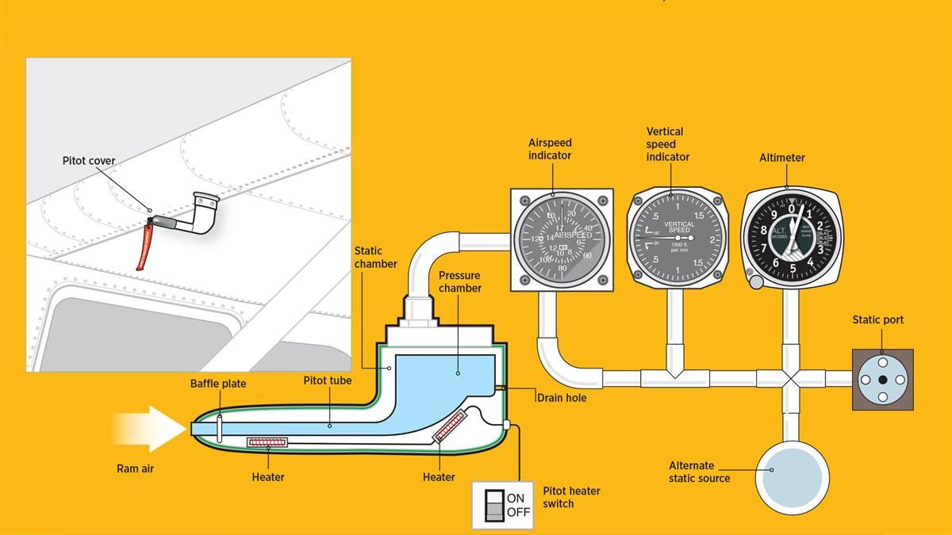

* The Airspeed Indicator:
  + A differential pressure gauge that measures the difference between impact pressure at the pitot tube and undisturbed atmospheric pressure in flight.
  + This leads to many different types of airspeed measurement
* **Indicated Airspeed (IAS):**
  + Airspeed read directly from the indicator
  + Uncorrected for errors caused by installation, differences in atmospheric density, instrument configurations
* **Calibrated Airspeed (CAS):**
  + Corrected for errors of the airspeed caused by position of the pitot and static source
  + Should be detailed in a table or graph in the pilots operating handbook that shows correction at different flaps settings.
* **True Airspeed (TAS):**
  + Corrects calibrated airspeed for temperature and pressure variations
  + As altitude increases, indicated airspeed decreases
  + Airspeed indicator will only show true airspeed at sea level on a standard day
  + **Rule of thumb:** True airspeed increases 2% over CAS every 1,000 ft
* **Airspeed specific markings**
  + **Green arc**: Normal Operating range
  + **Lower edge of green arc Vs**: Power-off stalling speed at max weight and flaps up
  + **Upper limit of green arc VNO:** Max structural cruising speed with flaps up and max weight
  + **Yellow arc:** Smooth air only regime
  + **Red line VNE:** Never Exceed.
  + **White Arc:** Flaps operating range
  + **Lower limit of white arc:** Power-off stalling speed; full flaps at max weight
  + Most likely these marking represent indicated speed, but for some planes they can be calibrated speed. Check the manual.
  + **Warning:** Maneuvering speed is not marked. It changes based on airplane weight so check the manual.

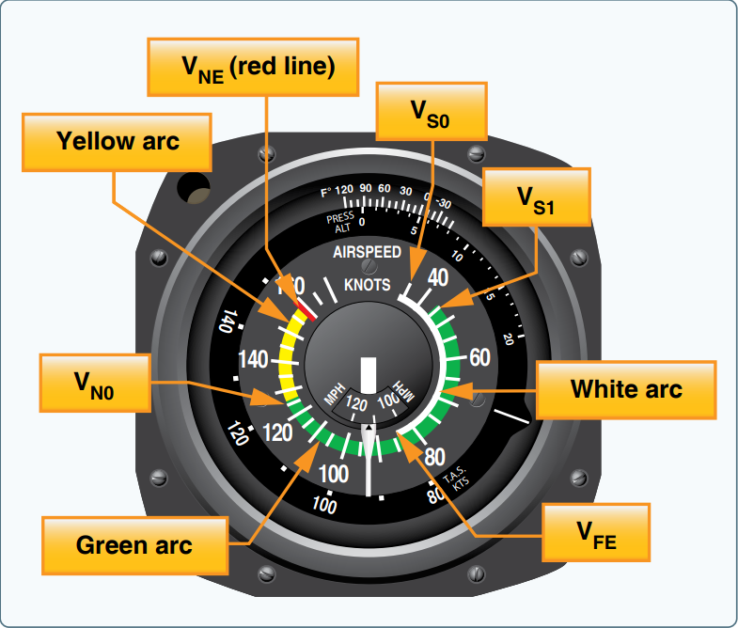

* **Altimeter settings:**
  + Given on the basis of sea level and equal barometric pressure only at sea level.
  + For high altitude airports this is what a barometer would read if it was in a pit dug downward to sea level.
* **Atmospheric Pressure Lapse Rate (**lower altitudes**):** 
  + Pressure changes approximately 1 inch of mercury per 1,000 ft
  + Changing the colesman window by 1 graduation changes the altitude reading by 1000ft in the same direction.

**Altitude types**

* **Indicated Altitude:** Read directly off of the altimeter with the correct pressure settings
  + Shows approximate height above mean sea level (MSL).
* **Pressure Altitude:** Shown on altimeter when set at 29.92 Hg
* **Density Altitude:** Pressure altitude corrected for non-standard temperature.
  + This is the altitude used for flight performance calcs
  + Warmer than standard temperature = relatively high density altitude
  + Colder than standard temperature = relatively low density altitude
* **Absolute Altitude**: Height above terrain also called AGL
* **True Altitude**: True vertical distance above mean sea level.
  + These are the altitudes shown on sectional charts and above ground
  + The calculation of true altitude are based on a standard temperature lapse rate 2 per 1,000 Feet

**Vertical Speed Indicator:**

* Measures the rate of change of pressure and shows a vertical change rate in ft per minute.
* Has a 6 – 9 second lag in reading accuracy

**Lesson 11: METARs and the Weather Depiction Chart**

* **Reports:** Conditions in the atmosphere observed at a specific time.
* **Meteorological Aerodrome Report (METAR):**
  + Report wind, visibility, precipitation, cloud coverage and altimeter setting
  + Is a routine weather report for an airport and issued, hourly
  + Based on international meteorological standards
  + **Speci:** A METAR that is indicated as special because weather conditions keep changing throughout the day.
  + Typically follow the **Where/ When / Wind**
  + First you will see airport designation preceded by a K, i.e. KRSW for FT. Meyers Florida
  + Second you will see the day and time of the observation. i.e 241953Z = 24th of the month, 19:53 coordinated universal time (UTC)
  + For wind first the direction it’s coming from is indicated, relative to true north, then the speed and gusting speed
  + **Example**: KRSW 241953Z 12015G20KT = Ft Meyers Florida, 24th of the month 19:53 UTC, with 15 – 20 knots gusting winds 120 of north
* **METAR visibility info:**
  + Comes after wind information
  + Can follow the form **Visibility in statute miles, Precipitation, Obscurations, Cloud layers, Temperature /and Dewpoint**
  + **Visibility:** Will be in SM and directly after wind
  + **Precipitation**
    - **RA =** Rain, -**RA =** Light Rain, **DZ =** Drizzle, **Ts =** Thunder storm
    - **SN =** Snow, **SG =** Snow Grains, **GR =** Hail
    - There are many more, to see more visit <http://www.moratech.com/aviation/metaf-abbrev.html>
  + **Obscurations = Fog or Mist**
    - **BR =** Mist, Any fog with greater than 5/8 SM visibility is called mist
  + **Cloud Layers:** Scattered, then Broken, then Overcast layer altitudes are reported.
    - **Example:** **SCT048 BKN065 OVC075 =** Scattered clouds at 4,800ft, Broken Ceiling at 6,500 ft, and Overcast at 7,500 ft
    - **Overcast is reported in eighths or Oktas**
      * **SKC =** Sky Clear, **FEW =** 1-2 eighths , **SCT =** 3-4 Eights , **BKN** = 5-7 Eighths, **OVC** = 8 Eighths full coverage
    - **Note**: The lowest broken or overcast layer is considered the cloud ceiling.
  + **Temperature and Dew Point**:
    - Reported in Celsius
    - **Example: 25/19 =** 25 ­C temperature / 19 C dew point
* After temperature Altimeter setting will be shown in inhg and then some Remarks
  + Example: **A3017 =** Altimeter setting 30.17
* **METARs Special Information and Modifiers**
  + **Runway Visual Range:** Gives the range of sight on a runway in feet
    - **Example:** **R04/2200FT FG** = Runway 04 has a visual range of 2,200 ft
  + **COR**: Indicates a correction to a prior METAR that day
  + **AUTO:** Automatic observation
  + **A01:** Station can’t tell freezing precipitation form normal
  + **A02:** Station can identify freezing rain/snow
  + **00000KT:** Calm winds
  + **Remarks:** Can indicate when a storm began or ended or some other weather event.
    - **Example: TSE36 PRESFR =** Thunderstorm began 36 minutes after the hour and pressure is now falling rapidly.
  + **V:** conditions vary
    - **Example:** **150V210 =** wind favors 150 but varies up to 210
  + **VRB:** Variable wind direction below 6 knots
  + **RVRNO:** Runway visual range not available
  + **SLPNO:** Sea Level Pressure not available

**Weather Depiction Charts:**

* Weather is classified as Instrument Flight Rules (IFR) when the ceiling is less than 1,000 ft and / or visibility is less than 3 statute miles.
* **Circles indicate cloud coverage**
  + Clear sky = empty circle
  + Few clouds = 1/4 circle filled in
  + Scattered clouds = 1/2 circle filled in
  + Broken ceiling = 3/4 circle filled in
  + Overcast = full circle filled in

**Lesson 12: Terminal Aerodrome Forecast (TAF)**

* These are forecasts originating at a single airport
* Follows a similar structure to a METAR,
  + Where, when, wind, visibility, weather, obstructions cloud coverage
  + **Main Difference:** TAF reports usually are valid for a 24 – 30 hour slot and broken into four 6 hour predictions of the conditions
* You can use a TAF for a 5-statute mile radius if no other airport TAF is present
* The most recent TAF overrules any prior ones
* **Special terms and contractions**
  + **AMD:** Amended TAF which corrects a previously issued one
  + **P6SM:** Indicates a visibility of plus 6 statute miles
  + **TEMPO:** Temporary conditions that last less than 1 hour at a time and total less than 1/2 the indicated time period
  + **PROB:** Probability percent of a weather event to occur between a time period given immediately afterwards
    - **Example: PROB30 2012/2018 5SM TSRA =** 30% probability of a thunderstorm between 12:00 and 18:00 UTC, on the 20th of the month, with 5 SM visibility.
  + **BECMG:** Becoming, usually issued by the U.S military to indicate transitioning weather
* Be careful for metric units in countries outside of the U.S

**Lesson 14: Intro to Glass Cockpit Systems**

* Feature two main screens
  + **Primary Flight Display (PFD):** On the left in front of the pilot and depicts flight instruments
  + **Multi-Function Display (MFD):** On the right and depicts GPS and navigational aids
* These are typically a Garmin G1000 system
  + Features two integrated avionics units (IAU)
  + These serve as a main communication hub that links the components
  + Each IAU has a nav receiver, com radio, and GPS receiver
* **Air Data Computer (ADC)**: the unit that processes info from the pitot-static system and outside air temperature (OAT) probe
  + the info given by this system is used for pressure altitude, airspeed, vertical speed, and OAT calculations
* **Attitude and Heading Reference System (AHRS):** Unit that replaces normal gyros
  + Computes attitude and heading using inertial and rate sensors.
  + Separate magnetometer is used for heading computations
* **Engine Monitoring Unit** **(GEA):** Processes engine signals and airframe sensors for
* **Transponder:** controlled from the PFD
* **Audio Panel:** located between both display
* **System Startup:**
  + System first powers up in PFD only mode during the pre-flight flight deck check. This is the reversionary mode and only shows engine instruments
  + After pressing the avionics switch the MFD should power on, press the proper softkey to turn on the display fully

**Lesson 15: Airport Signs and Markings:**

* There was a horrible aviation accident on Tenerife Island on March 27, 1977, check it
* Every airport with a control tower has an FAA airport diagram showing parking and taxi areas, along with runways
* **Nonmovement area:**
  + Usually, a parking area ramp
  + Not controlled by ATC, so you can taxi around at your discretion
  + Has a **boundary with a solid line and a broken line on the taxiway side**
    - **Warning:** You need ATC clearance to cross the solid line
* **Taxiway:** A route identified by letter that leads to a runway
  + Features double yellow edge lines and a single solid yellow centerline
  + **Taxiway Direction Sign:** **Black text on a yellow background,** indicating the nearby taxiway
  + **Taxiway Location Sign: Yellow text on a black background**, whichindicates the taxiway you are currently located on
  + **Taxiway intersection:** Will have two signs, one for the taxiway you are on and the intersecting taxiway
  + **Taxiway Holding Position Line:** A dashed line that you must stop before if ATC instructs you to “Holds short” of the intersecting taxiway
* **Taxiway to Runway Intersection:**
  + **Runway Holding Position Marking:** Identified by two solid and two dashed yellow lines
    - May have flashing yellow guard lights on the side or on the pavement
    - **Warning:** You must stop here until given clearance by ATC to cross the solid lines
  + **Enhanced Centerline:** Yellow dashes on the centerline’s sides up to 150 ft before the hold short line
  + **Runway Holding Position Sign/Marking:** A red sign/ ground marking which identifies the runway you are approaching
    - If a taxiway intersects a runway not at it’s end, there will be two runway numbers on the red sign pointing respectively
  + **Instrument Landing System Critical Area:** A ladder shaped hold short marking that identifies where an airplane could interfere with ILS radio signals
    - **Warning:** You must stop here if instructed by ATC
  + **Approach Area Holding Position Sign:** An area that ATC may need to keep clear to watch planes making their turns to final
    - Has a red sign with APCH written on it
    - **Warning:** Hold short if assigned by ATC, or ask ATC if you must.
* **Displaced Threshold:**  An area with white arrows that indicate where the landing section of the runway starts further down from the edge of the pavement
  + These are used to indicate an obstruction that is close to the pavement
  + Can be used for takeoff but not landing touchdown
  + Indicated on a chart supplement by **two ovals** on the side of the runway
  + Sometimes a Taxiway will precede the runway, only start takeoff when on the runway section
* **Runway Distance Remaining Sign:** A black sign with a white number to show how much runway is remaining
  + **Note:** The number represents how many **thousands of feet remain**
* **Taxiway Direction Sign:** Shows where the taxiway is to exit the taxiway
  + You must cross the dashed yellow lines to exit the runway after landing

**Lesson 17: Thunderstorms and Convective Forecasts**

* **Thunderstorm Development:** Created by a combination of unstable air, high moisture content, and a source of lift
* **3 Stages:** Cumulus, Mature and Dissipating
  + **Cumulus:** Consists entirely of cloud updrafts
  + **Mature:** Starts when precipitation first occurs and is characterized by both updrafts and downdrafts.
    - **Warning:** Hazards such as hail, lightning and turbulence intensify during this.
  + **Dissipating Stage**: Mostly downdrafts as the thunderstorm dies
* **Steady State Thunderstorms:** Continuously regenerate and are in all three stages simultaneously
  + Can be along long fronts and prefrontal squall lines
  + The leading edge is in **Cumulus Stage**
  + the center is in **Mature Stage**
  + The trailing edge is in the **Dissipating Stage**
* **Thunderstorms can have all hazardous weather flying conditions**
  + **Turbulence**: The strongest shear turbulence is where updraft and downdrafts meet
  + **Downdrafts**:Can drag other air and planes near the storm down and cause microbursts
  + **Hail**: Common under the anvil top of a storm and can be found miles away from an advancing storm
  + **Low Ceilings and Visibility**: Caused by precipitation and dust between the cloud base and ground
  + **Lightning**: Can puncture the plane’s skin, blind you, or knock out avionics
  + **Pressure Discrepancies:** Can cause altimeter errors due to the storm being a localized low-pressure region
* **Convective Outlooks:** National thunderstorm forecasts issued by the national storm prediction center in Norman, OK
  + Outlines areas where thunderstorms may occur
  + **Day 1, 2, and 3 outlooks** depict areas with a 10% chance of storms developing
  + **Shade Color Coding:** Best to Worst thunderstorm outlook
    - **Light Green Shading:** General thunderstorm Activity
    - **Dark Green:** Marginal severe risk
    - **Yellow:** Slight severe risk
    - **Orange:** Enhanced severe risk
    - **Red:** Moderate severe risk
    - **Magenta:** High severe risk
  + **Day 1 outlook:** Issued 5 times daily
  + **Day 2 outlook:** issued twice daily
    - Each outlook is good from 12:00 UTC of one day to 12:00 UTC of the next day.
* **Convective SIGMETs:** Significant Meteorological Information (**SIGMET**)
  + Gives info on active thunderstorm systems
  + Issued hourly for:
    - **lines of thunderstorms**
    - **Embedded thunderstorms**
    - **Heavy intensity thunderstorms that affect at least 40% of an area**
    - **Tornadoes**
    - **Surface winds of 50 Knots**
    - **¾ in hail or larger**
  + Unscheduled bulletins are issued as required
  + If there is no observed or forecast convective activity, it will say “none”

**Example:**

**MKCE WST 171655**

**CONVECTIVE SIGMET 45C**

**VALID UNTIL 1855Z**

IA NE

FROM 20NE SUX-10SE OMA LINE SVR TSTMS 20MI WIDE

MOVF FROM 2235 TOPS ABV 450.

TORNADOES… HAIL TO 3 IN… WIND GUSTS TO 70 KT PSBL

**TRANSLATION:** Convective SIGMET 45C issued at 16:55 Zulu, valid until 18:55 Zulu, for Iowa and Nebraska

A line of severe thunderstorms 20 miles wide is moving from heading 22 at 35 knots, with tops above 4,500 feet

Tornadoes, hail up to 3 inches, and gusts up to 70 knots are possible